Dragon Attack

Game design document

GAM150S18

Spring 2018

Team D-Sync

|  |  |  |
| --- | --- | --- |
| **Student Name** | **Official Role** | **Coding Responsibilities** |
| Jacob Lim | Producer | Graphics and AI Designer |
| Javon Lee | Technical Director | Framework and Tools |
| Andrew Chong | Lead Designer | Level Designer |
| William Yoong | Product Manager | AI Designer |

**Table of Contents**

**Table of Contents** 1

**High Concept** 3

**Summary** 3

**Story (TBD)** 4

**Game Flow** 4

Title screen 4

Main Menu 4

Stage Selection 4

Gameplay 5

Difficulty Curve 5

Scoring (Low Priority) 6

**Game Mechanics** 6

Character Movement 6

Character Attack 6

Win Conditions 6

Lose Conditions 7

Scoring System (Low Priority) 7

**Game Characters** 7

Player Character / Bob 7

Merlin 7

King Arthur 7

**Game Resources** 7

Enemies 7

Power-ups 7

Items 7

Bosses 7

Platforms 8

Hazards/Dangers 8

**Game Environment** 8

Courtyard / Gatehouse 8

Inner Keep / Grand Library 9

Grand Corridor / Throne Room 9

**Game Controls** 9

Mouse 9

Keyboard 9

**Visual Design** 9

Art style 9

Camera Position 9

**Audio Design** 10

Audio Style 10

**Behaviour Design** 10

Enemy AI 10

Basic Types 10

Advanced Types 10

Bosses 10

**Physics Design** 11

Physics 11

Gravity 11

Collision 11

**Appendices** 11

# **High Concept**

Dragon Attack is a single-player 2D action platformer set in a medieval fantasy environment.

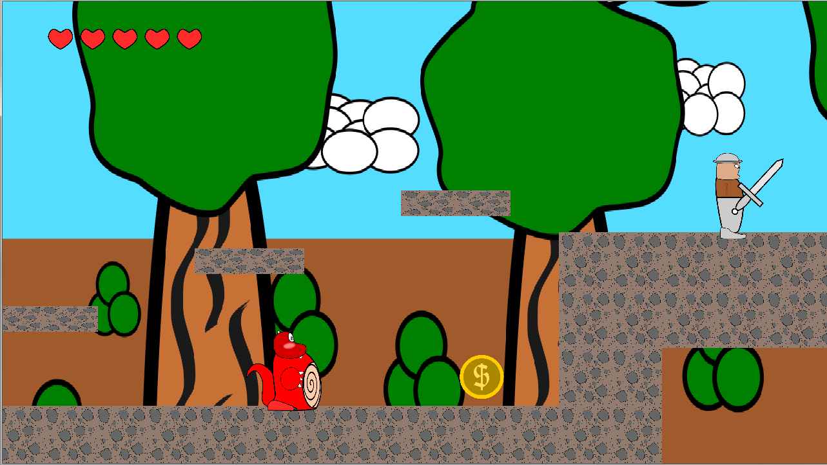

# **Summary**

Dragon Attack is a **2D action platformer** where the player plays as a young dragon attacking a castle to gain its treasures. The objective of the game is to defeat the King of the castle and gain his treasures.

# **Story**

A screenshot of a cell phone

Description generated with very high confidenceIn a fantasy realm, a young dragon named Bob has been constantly belittled for his extremely underwhelming name. So, he sets out to conquer the castle of the most famous king of the realm, King Arthur and steal his treasures and in doing so, prove himself.

Figure 1 Overall Game Loop

# **Game Flow**

## Title screen

This will include the DigiPen logo and the team logo and the game’s title.

## Main Menu

The main menu will include Play, Stage Select, Help, Volume and Credits.

## Stage Selection

The stage selection screen will allow players to select from up to 9 sub-stages, with 3 main stages split into 3 sub-stages each.

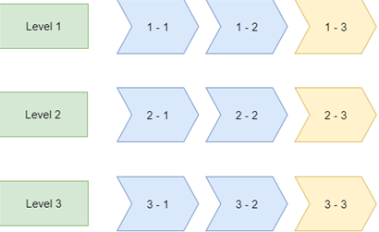

Figure Stage structure of our game

As seen in the picture above, the game is split into 3 main stages which are further split into 5 sub-stages. The blue sub-stages represent normal stages, the yellow sub-stages represents a mini boss fight and the red represents the main boss fight.

# **Gameplay**

The player only has a basic ‘Fire Ball’ attack. The player will need to use it and the platforms in the environment to overcome enemies and bosses. The quantity of enemies will slowly increase, and difficulty will gradually increase as well until it hits a difficulty ceiling.

## Difficulty Curve

Enemies

Enemies will gradually increase in quantity and variety as the game progresses. Enemies will be coming at the player from the right side of the screen. However, there will be some who have ranged abilities and are stationed on platforms above the player. Different enemies require different methods of dealing with them.

Environment (Low Priority)

As the player progresses into the game, some platform puzzles will be introduced. These puzzles will have traps like spiked ceilings, wall arrows and ground spears. Players who solves the puzzles will receive a lot of coins or temporary power-ups.

Temporary Power-Ups/Heal

Power-Ups and Healing Items can be found throughout the game. These Power-Ups gives the player improvements like Increased Damage, Increased Movement Speed or Invulnerability. Healing items in the form of food are laid throughout the map.

Boss Battle

There are Stage Bosses at the end of the stage. The Stage Boss will have special skills unique to him and will have 2 phases. The Stage Boss will test the player’s skill with the mechanics.

## Scoring (Low Priority)

At the end of each sub-stage, players will be able to see their total score they’ve gained from the sub-stage. Scores are calculated by the enemies you kill and the coins you collect.

# **Game Mechanics**

## Character Movement

The character can move left, move right and jump.

## Character Attack

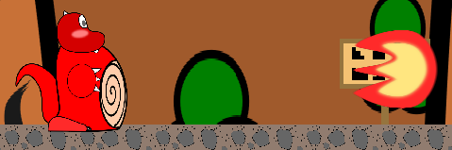

The player character will have a basic attack, a ranged fireball attack and a charged ‘Mega Fireball’ attack that only becomes available when the player fills up a bloodlust meter by landing successful hits. It is a high damage attack that will reset the meter after use.

## Win Conditions

Main Objective – Defeat King Arthur.

Sub Objectives – Clear stages and defeat bosses.

## Lose Conditions

When the player’s health reaches zero, the player loses.

## Scoring System (Low Priority)

Score is based on coins and the enemies you defeat. Depending on the player’s remaining health, a multiplier will be applied to the final score.

# **Game Characters**

## Player Character / Bob

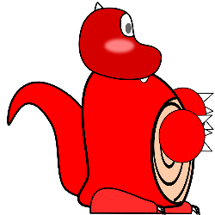

Bob is a dragon. Bob’s name is too underwhelming, in terms of dragon culture. He has no treasures to lord over and is constantly being looked down upon by other dragons.

## Lancelot

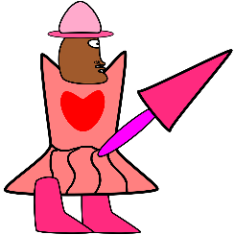

Lancelot is a cross-dressing knight under the service of King Arthur. Despite his quirks, he is well-known as King Arthur’s right hand man, defending the kingdom with his trusty lance Arondight

## Merlin

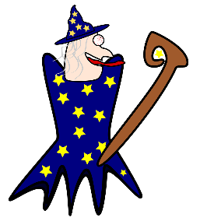

Merlin is the arch wizard of King Arthur’s kingdom. He is a few hundred years old and knows a variety of dangerous magic spells.

## King Arthur

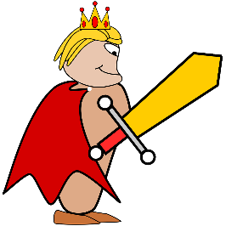

King Arthur is the strongest human in the human realm and the King of the castle that Bob attacks. He owns a huge amount of wealth and treasures.

# **Game Resources**

## Enemies

|  |  |
| --- | --- |
| ILLUSTRATIONS | DESCRIPTION |
| C:\Users\william.yoong\Desktop\drqst\Production\Illustrations\Grunt\Grunt.png | Soldier   * Normal moving speed, attack, low health points. |
| **C:\Users\william.yoong\Desktop\drqst\Production\Illustrations\Grunt\Archer.png** | Archers   * Slow moving speed, long range attacks, normal health points. |
| C:\Users\william.yoong\Desktop\drqst\Production\Illustrations\Knight\Knight.png | Knights   * Slow moving speed, fast attack, high health points |
| C:\Users\william.yoong\Desktop\drqst\Production\Illustrations\Mage\Mage.png | Mages   * Ability to teleport short distances, long ranged attack, low health points. |

## Power-ups

|  |  |
| --- | --- |
| Power-Ups | Descriptions |
| C:\Users\william.yoong\Desktop\drqst\Production\DragonAttack\DragonAttack\Textures\spd.png | Speed Up (Common) – Increased movement speed. |
| C:\Users\william.yoong\Desktop\drqst\Production\DragonAttack\DragonAttack\Textures\invul.png | Shield Bubble (Rare) – Makes the player invulnerable for some time. |
| C:\Users\william.yoong\Desktop\drqst\Production\DragonAttack\DragonAttack\Textures\Fireball.png | Attack Up (Rare) – Increased attack for some time. |
| C:\Users\william.yoong\Desktop\drqst\Production\DragonAttack\DragonAttack\Textures\hp.png | Heart (Common) – Increase the player HP by 1 |
| C:\Users\william.yoong\Desktop\drqst\Production\DragonAttack\DragonAttack\Textures\coin.png | Coin(Common) – Increase the player score that will be calculated at the end of the stage |

## Bosses and Abilities

|  |  |  |  |
| --- | --- | --- | --- |
| **Boss Phases** | **Stage 1 Boss : Lancelot** | **Stage 2 Boss : Merlin** | **Stage 3 Boss : King Arthur** |
| Default | Slash / Stab | Blink | Single slash wave / Triple Slash wave |
| Phase 1 | Mad Enhancement | Energy Ball | Dash Attack |
| Phase 2 | Arondight | Arrow Rain | Regeneration and Call Allies |
| Phase 3 |  |  | Homing swords |

## Platforms

There will be platforms present in normal stages to facilitate in player movement and platforms in boss fights to allow the player to dodge attacks and plan their next move.

## Hazards/Dangers (Low Priority)

While there will be some hazards and dangers in all of the stages, the main point of it is to be combined with platforming puzzles to give players a sense of risk vs reward.

# **Game Environment**

Dragon Attack will feature 3 main stage with different themes. Each stage will feature new enemies and different mechanics and behaviours.

## Courtyard / Gatehouse

This stage will feature outdoor areas that the player will have to fight through to reach the gates. These areas will generally feature weaker enemies to serve as a tutorial for the player to learn the controls. As the player reaches the gatehouse, the environment will change to feature more castle-like environments. These areas will feature enemies like dogs and lightly armoured soldiers.

The mini boss of this stage will be a large dog and the final boss of this stage will be the guard dog ‘Cerberus’.

## Inner Keep / Grand Library

This stage will feature castle interiors which the player moves through to get to the throne room. The enemies in these areas will include soldiers and archers. Upon reaching the grand library, mages will appear as a new ranged enemy type.

The mini boss of this stage will be a wizard and the final boss of this stage will be the arch wizard ‘Merlin’.

## Grand Corridor / Throne Room

This stage will feature majestic castle interiors as players make their way toward the throne room. The enemies in these areas will include all the enemy types featured previously as well as more challenging variants, like the knights. This serves to challenge the player and test their understanding of the mechanics and controls.

The mini boss of this stage will be a black knight and the final boss will be King Arthur.

# **Game Controls**

## Keyboard

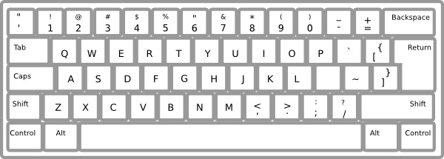

**Movement:**

A - Move left

D - Move right

SPACEBAR – Jump

**Combat:**

ENTER – Fireball

P – Mega Fireball (only when blood lust meter is filled)

# **Visual Design**

## Art style

Dragon Attack aims to go for a pixel art aesthetic.

## Camera Position

Camera will follow character.

Camera will have a pre-animation zoom and pan out for stages with boss fights.

# **Audio Design**

## Audio Style

Fantasy folk music, with comedic elements

# **Behaviour Design**

## Enemy AI

All enemies’ line of sight will be determined by the camera’s position.

### Basic Types

Basic melee enemies like the soldiers will have a basic patrol pattern. Only once the player comes within a specific range will they move toward the player, and once the player is in attacking range will they attack the player.

Basic ranged enemies like the archers will have a stationary position. Once the player comes within a specific range, they will start firing toward the player.

### Advanced Types

Advanced melee enemies like knights will spawn in certain positions that do not patrol the stage but always face a certain direction. Once the enemy comes into view, they will move slowly toward the player and try to attack them defensively as they have a shield to protect them.

Advanced ranged enemies like mages will have a stationary position. Once the player comes within a specific range, the will move closer and attack from a short distance. They will try to escape once the player is too close by teleporting a short distance away.

### Bosses

Each boss fight will have 2 phases. They will have basic attacks and a unique move in each phase.

Phase 1 will start as the fight begins, with each specific boss having their own mechanics.

Phase 2 will start as the boss’s health reaches 50%.

**Lancelot** will only have melee attacks as it is the first boss. He has two default attacks which are slash and stab.

In phase 1, its attacks include mad enhancement, which cause Lancelot to move faster and have no idling time.  
In phase 2, Lancelot switches from mad enhancement to Arondight, where he shoots his lance to the sky and bring it down, covering either half of the left side or ride side of the screen.

**Merlin** will have a set of ranged attacks and a basic melee attack that he will only use if the player is nearby. He would also be able to blink throughout the fight and do so every few moves.

In phase 1, his ranged attacks will consist of a single-shot energy ball and spread-shot energy ball.

In phase 2, Merlin would employ his remaining magical energy and start using his ultimate move – arrow rain. A magic circle would appear in the sky and shower down arrows on his enemies.

**King Arthur** will have a basic attack that employs his magical sword that deals physical damage and fires magical projectiles.

In phase 1, he can slash and triple slash. Slashes can be avoided with one jump. Triple slashes can’t be avoided with one jump – the player must jump on a platform to avoid it.

In phase 2, he will use the Pillar of Light attack that will beam down light pillars into the boss arena. The Call Allies attack will allow King Arthur to call enemy reinforcements while he moves away to regenerate his health. His regeneration can be disrupted if he receives damage. In addition, all his abilities from phase one can still be used.

# **Physics Design**

## Physics

### Pseudo Gravity

Pseudo gravity will be simulated in the game to facilitate the jumping dynamics for the platform elements and it will also affect in-game projectiles like arrows, causing it to curve downwards and have an entropy effect.

### Collision

All game objects would have a collision factor that would run through the collision engine to detect collisions. When the player is damaged by any collision, they will be pushed back slightly and given invulnerability for a split second.

# **Appendices**

For any additional aspects of design that do not fit any of the above categories.